Upgrade clone grafana version

-> open clone Access first & use pid credentials to login .

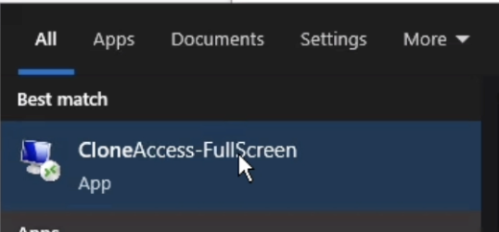  
  
-> After logging in successfully, choose your workstation. If you want to log in to a specific server, you can directly click on "Unix-Linux Server" and enter the host details, then click "Open."

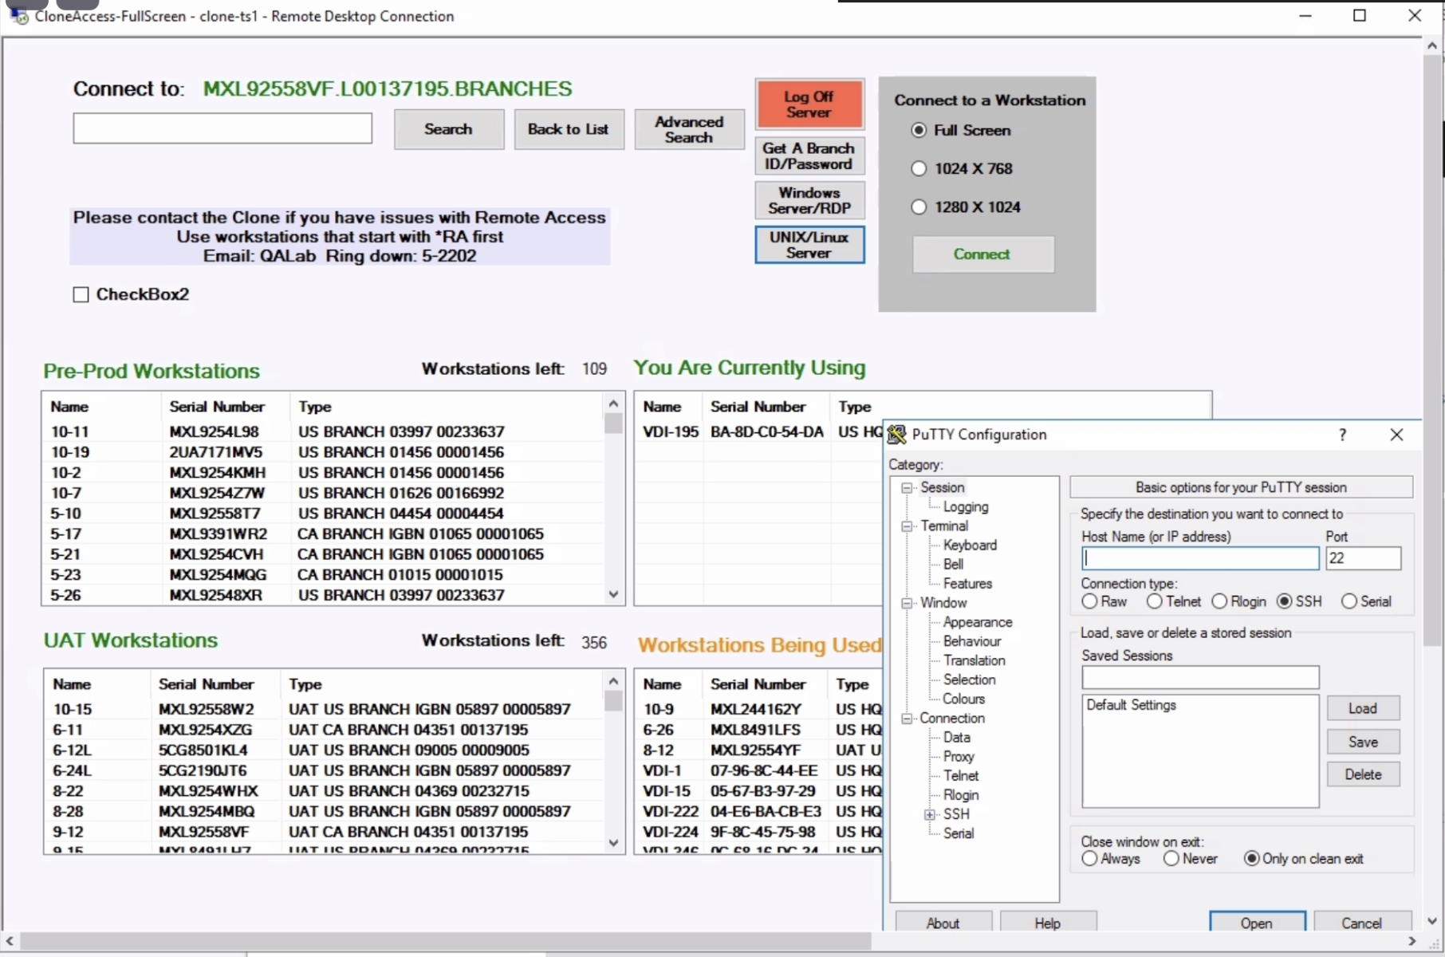

-> Currently mallory is login this server :- **tlpibmmq-001.edj.ad.edwardjones.com  
->** She is using her PID and credentials. After entering those credentials, she received a message on her phone with an OTP. 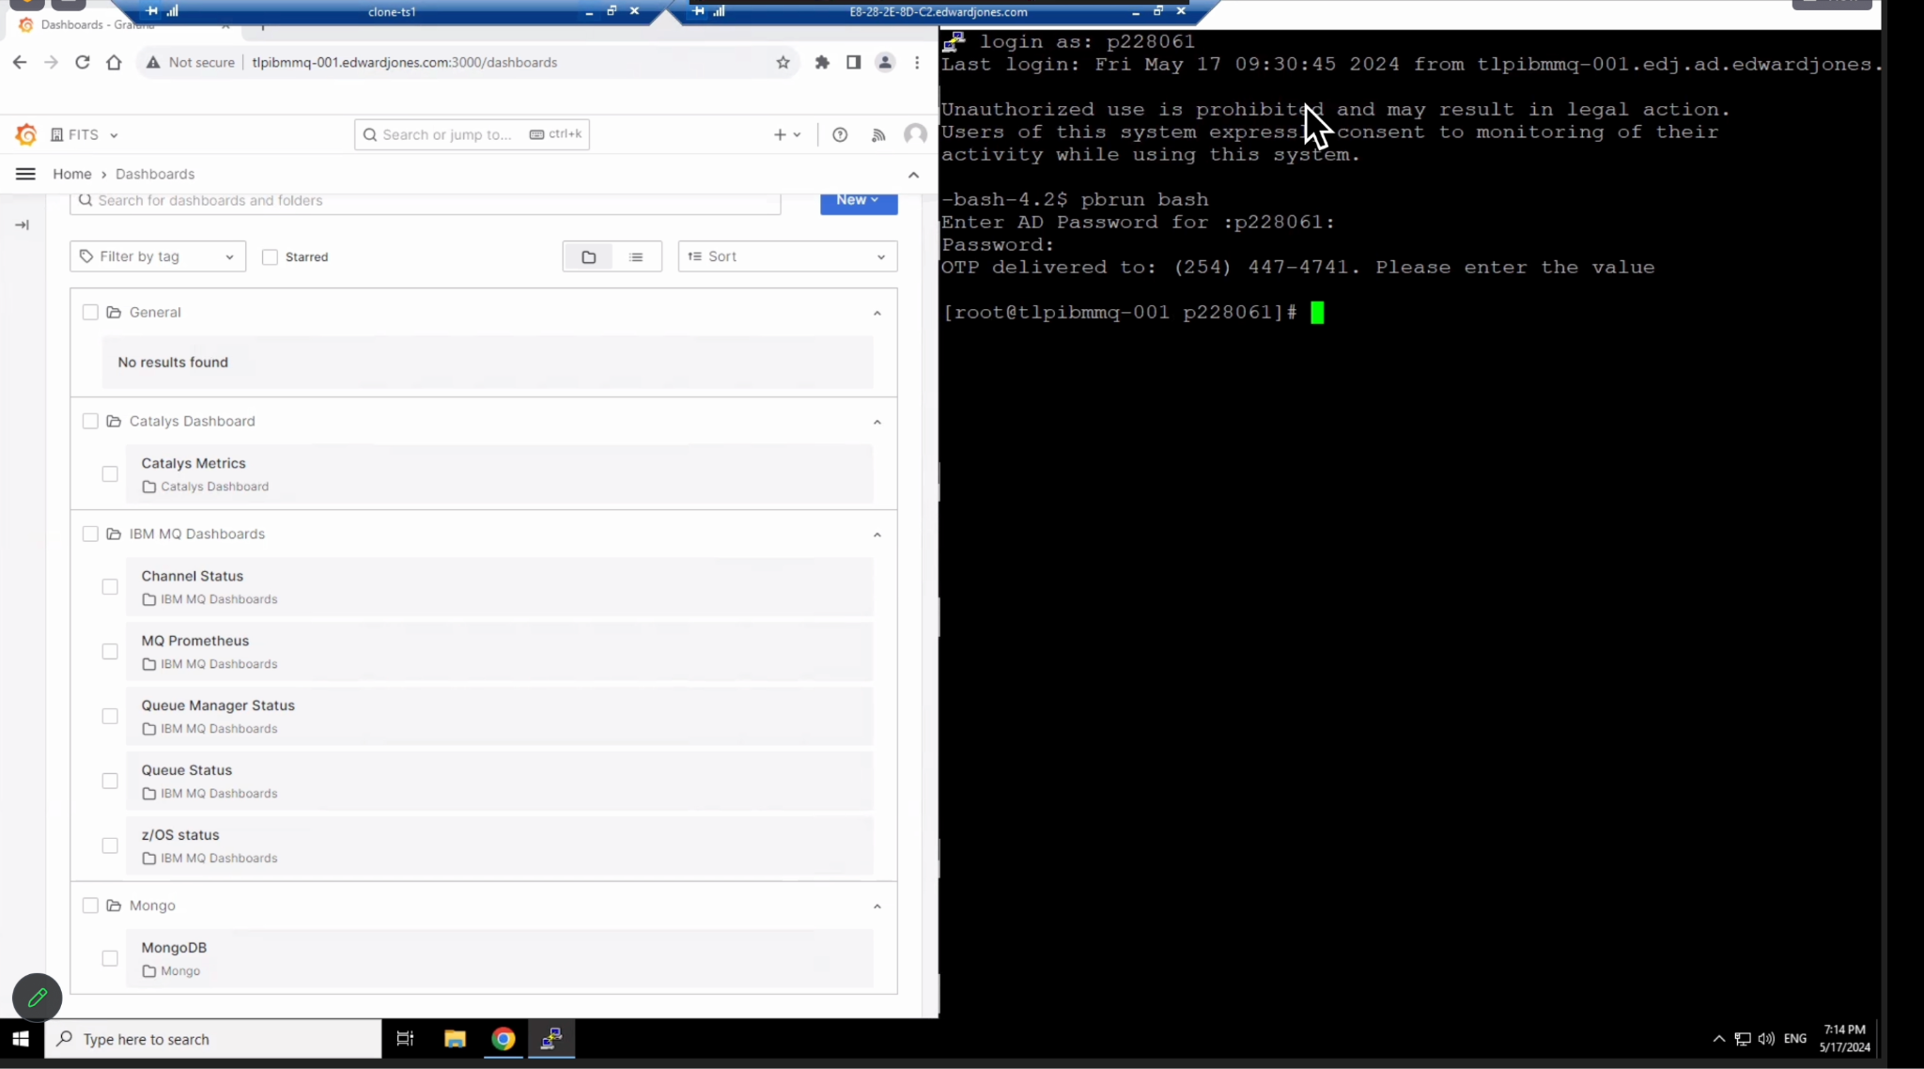

-> run **pbrun bash**  
